**拓扑**

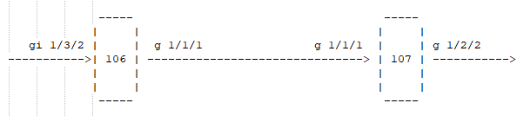

106设备1/3/2口接仪表打流，在107设备1/2/2口抓包验证是否同一报文。

**配置命令**

**106设备配置**

port allocate internal-port gchip 0 type iloop

nexthop add iloop 79 lpbk-lport 79

port allocate internal-port gchip 0 type eloop nhid 79

l3if create ifid 99 type phy-if gport 79

l3if ifid 99 mpls-property mpls-en value 1

l3if ifid 99 router-mac 0000.0000.0002

nexthop add arp-id 10 mac 0.1.2 vlan 2 gport 79

nexthop add mpls-tunnel 13 working-path arp-id 10 label1 16 ttl1 255 exp1 0 exp1-type 1

nexthop add mpls 23 push fwd payload-op op-l2vpn cvlan-edit-type 0 svlan-edit-type 0 output-cvid 0 output-svid 0 tunnel-id 13 label1 100 ttl1 255 exp1 0 exp1-type 1

port 1 scl-key-type scl-id 0 direction ingress type svid

vlan mapping add port 1 svid 10 mapping-to nexthop 23

overlay-tunnel vn-id 1000 fid 4096

l2 fdb add vlan-default-entry fid 4096 group 4096 use-logic-port

port 79 scl-key-type scl-id 0 direction ingress type svid

vlan mapping add port 79 svid 2 mapping-to vn-id 1000 logic-port 500 scl-id 0

nexthop add arp-id 20 mac 000E.5E6B.0004 gport 27

nexthop add ipuc 30 fwd arp-id 20

ipuc add 0 10.10.10.10 32 30

nexthop add ip-tunnel 10 dsnh-offset 10 fwd arp-id 20 type tunnel-v4 vxlan strip-vlan ipsa 1.0.0.2 ipda 1.0.0.1 dscp 0 dscp-select 0 ttl 10 map-ttl logic-dest-port 1000

l2 fdb add mac 0.0.2 fid 4096 nexthop 10 static

l2 fdb logic-nhid logic-port 1000 nexthop 10

l2 fdb vlan-default-entry fid 4096 add nexthop 10

**107设备配置**

port allocate internal-port gchip 0 type iloop

nexthop add iloop 79 lpbk-lport 79

port allocate internal-port gchip 0 type eloop nhid 79

l3if create ifid 99 type phy-if gport 79

l3if ifid 99 router-mac 0000.0001.0002

l3if ifid 99 mpls-property mpls-en value 1

mpls ilm add space 0 label 16 pop

nexthop add egs-vlan-edit 106 dsnh-offset 106 port 49 cvlan-edit-type 0 svlan-edit-type 3 output-cvid 0 output-svid 10 svlan-valid

mpls l2vpn-pw add 100 vpws 106 encapsulation-mode tagged

overlay-tunnel vn-id 1000 fid 4096

l2 fdb add vlan-default-entry fid 4096 group 4096 use-logic-port

port 79 scl-key-type scl-id 0 direction ingress type svid

vlan mapping add port 79 default-entry mapping-to user-vlanptr 0x1063

port 27 scl-key-type scl-id 1 direction ingress type vxlan

overlay-tunnel add vxlan src-vnid 1000 ipda 1.0.0.1 ipsa 1.0.0.2 dst-vnid 1000 tunnel-src-port 1000 scl-id 1

nexthop add egs-vlan-edit 20 port 79 cvlan-edit-type 1 svlan-edit-type 3 output-cvid 1 output-svid 2 svlan-valid logic-dest-port 500

l2 fdb add mac 0000.0001.0002 fid 4096 nexthop 20 static

l2 fdb logic-nhid logic-port 500 nexthop 20

l2 fdb vlan-default-entry fid 4096 add nexthop 20

**报文流水**

**仪表报文**

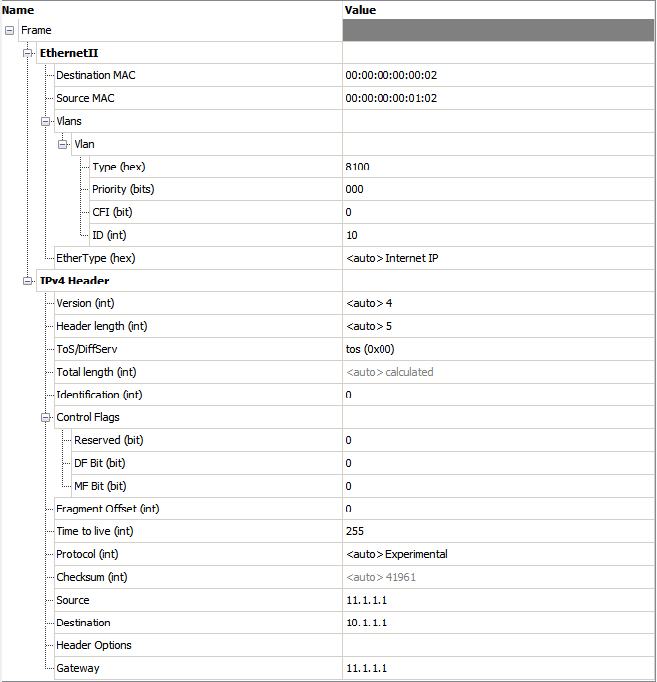

**106 设备sdk收发统计**

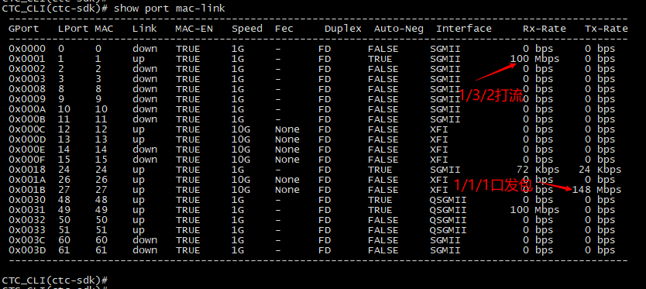

**106设备1/1/1口发出报文**

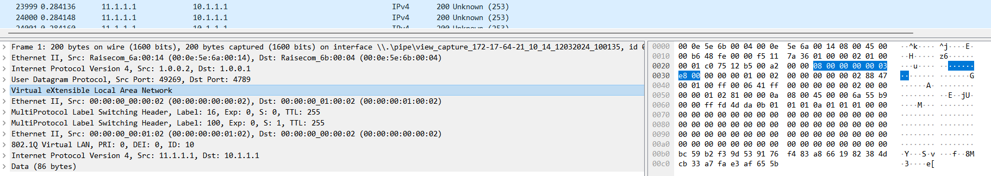

**106设备loop口芯片流水**

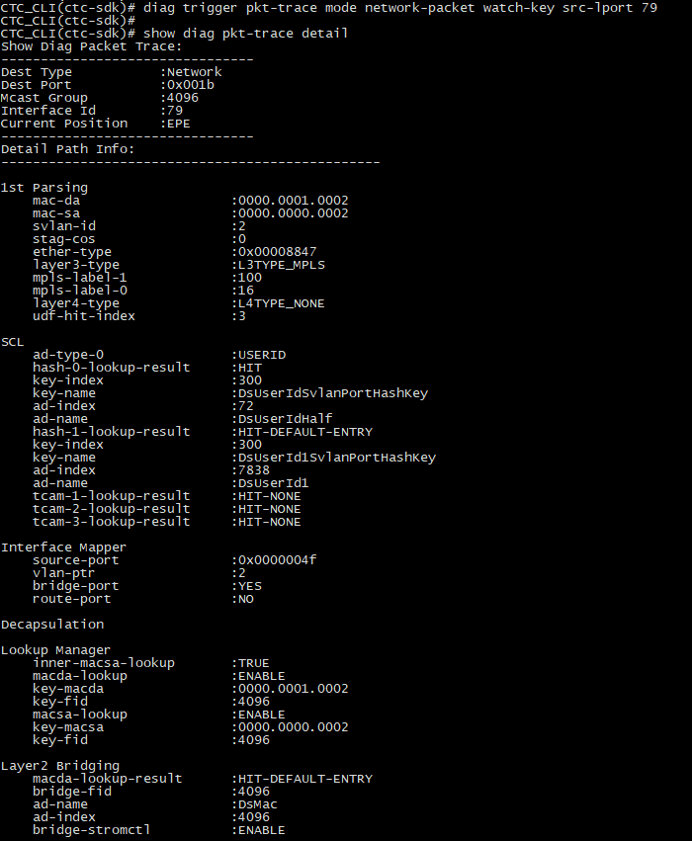

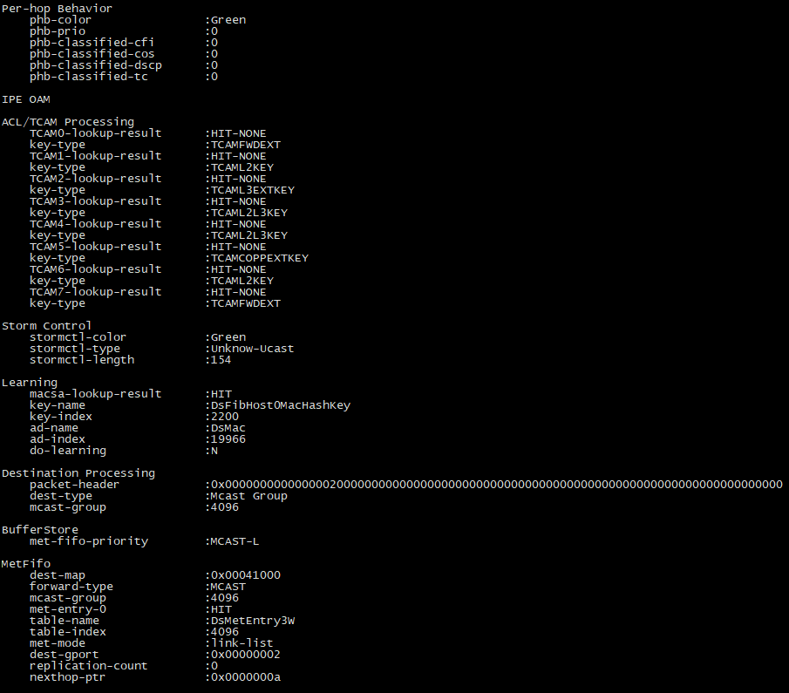

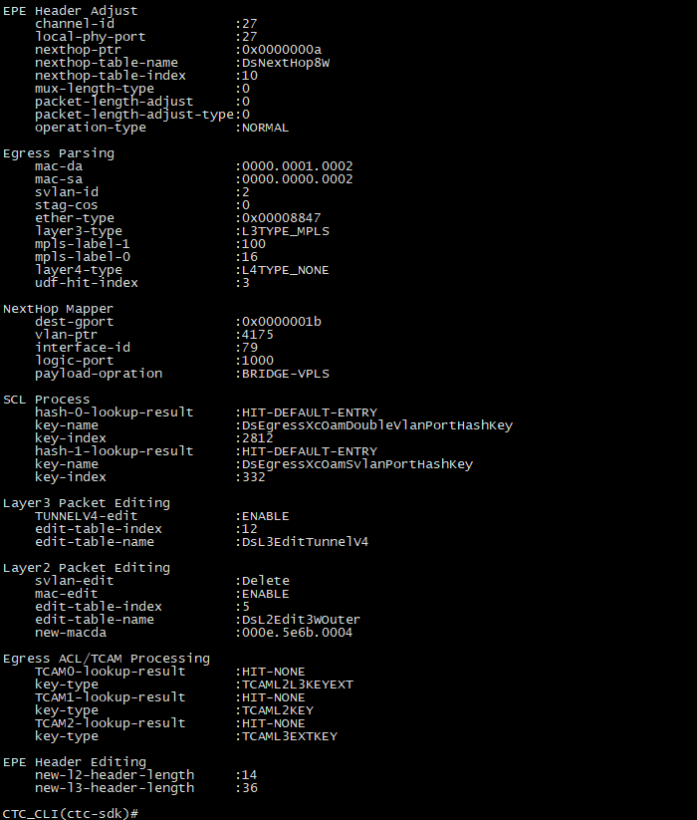

**107 设备sdk收发统计**

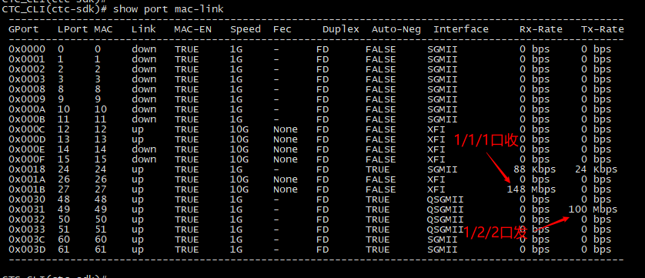

**107设备1/2/2口发出报文**

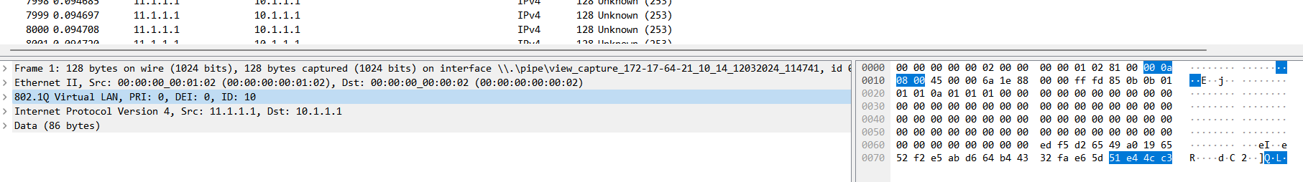

**107设备1/1/1口收包芯片流水**

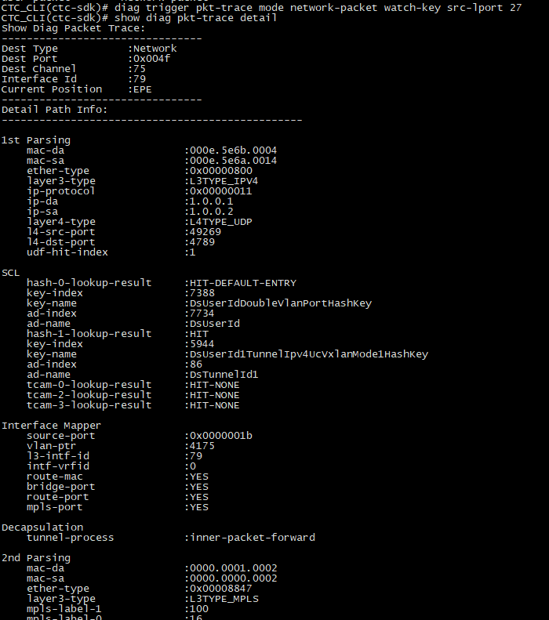

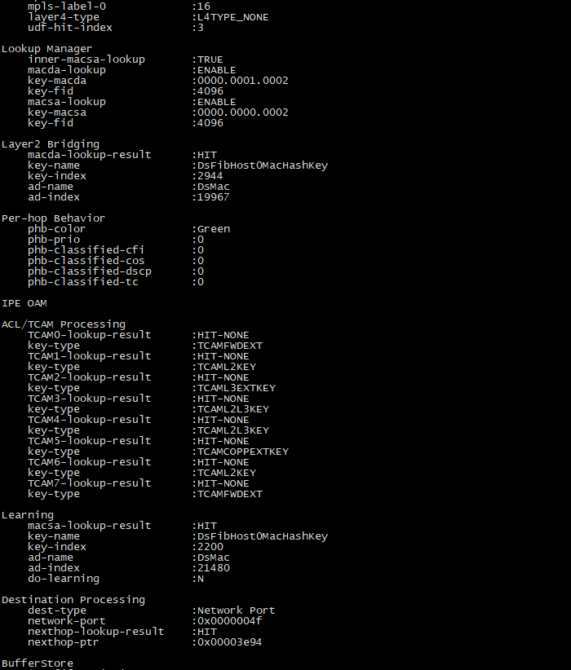

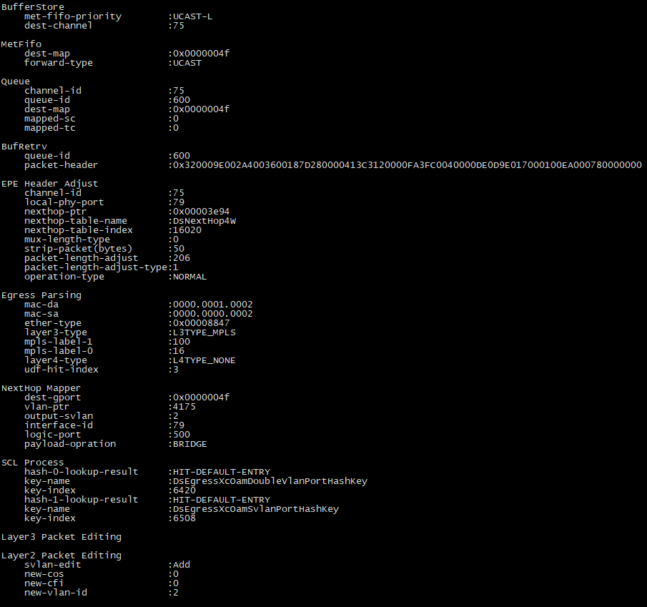

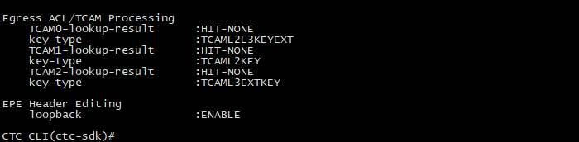

**107设备loop口芯片流水**

